CIS580 HW 3

Shang Shi

I used Intellij for this HW. The test case file is located in Test folder under JUnitTest.java file. If I run this file, I got result like this.

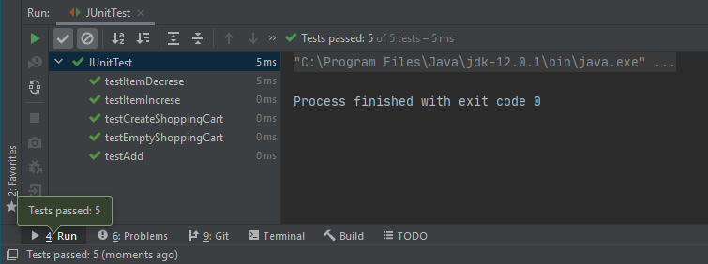

Figure . Run JUnit Result.

The JUnit setting I used is shown in figure 2.

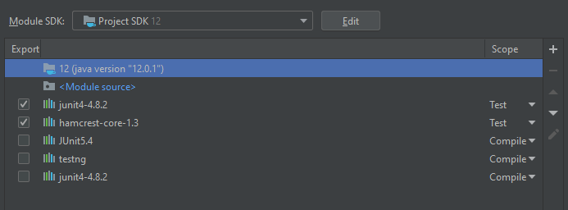

Figure . JUnit Config

The Test file looks like below screenshot, also the entire repo is attached.

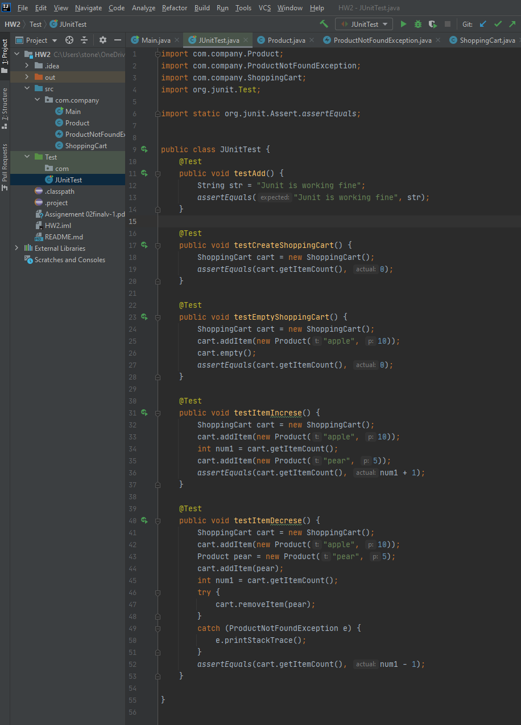

Figure . JUnit Test File